**Warnath Group Develops Child-Friendly Spaces in Manuel Mora Valverde Hospital, Costa Rica**

Inside its own section of Golfito Hospital, a large, gentle sea turtle welcomes visitors to the child-friendly spaces corridor. An ombre of blue waves flows through the space. In those waves swim a vast array of sea creatures – sharks, stingrays, fish, jellyfish, whales, and dolphins. These sea creatures have the same job as everyone else staffing the child-friendly spaces in the Golfito hospital: to provide child and adolescent trafficking victims a safe and reassuring environment in which they can receive medical care and emotional support.

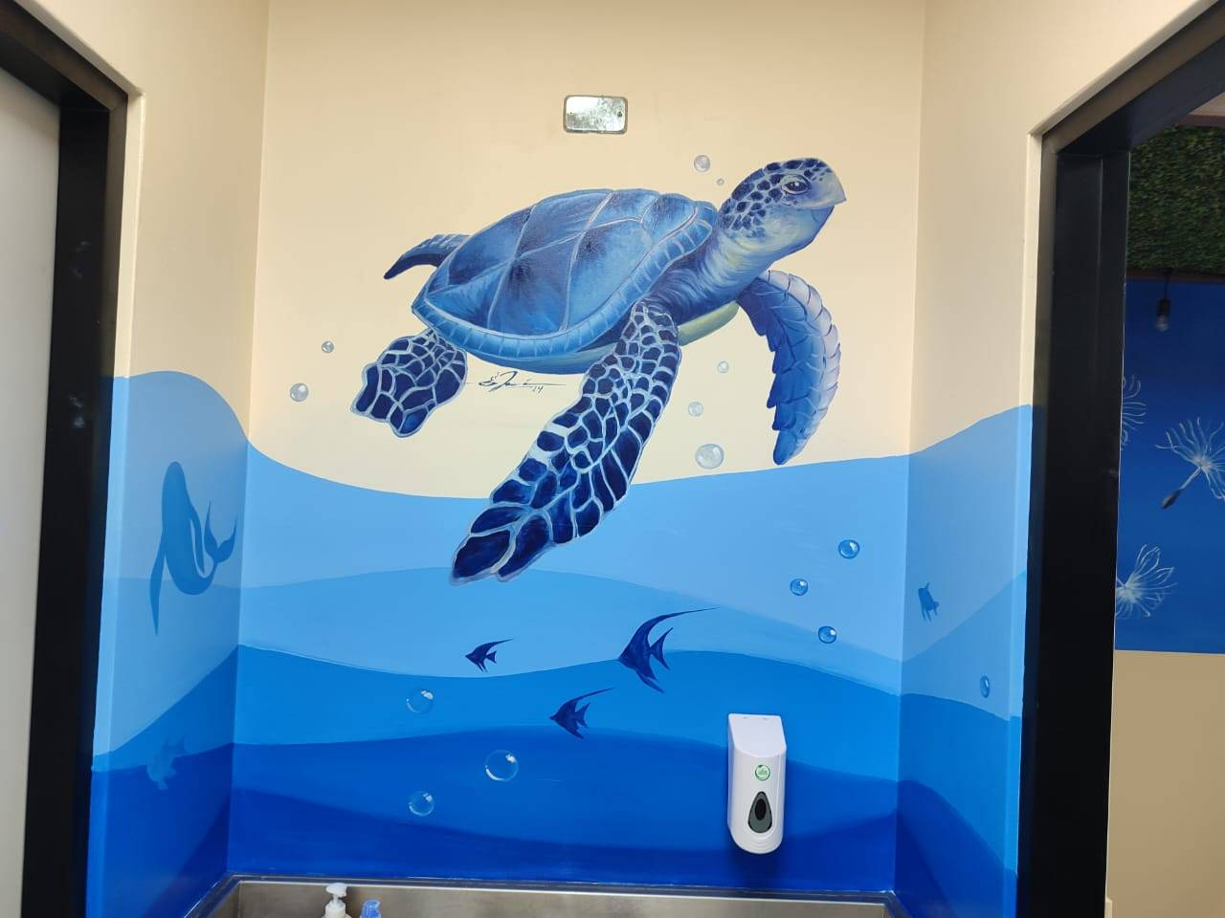

The child-friendly spaces corridor and the adjoining child-friendly spaces are the result of a collaboration between the Manuel Mora Valverde Hospital in Golfito and the Warnath Group’s Innovations in Addressing Child Trafficking Program (IACT), being implemented in the provinces of Guanacaste and Puntarenas with funding from the United States Department of State Office to Monitor and Combat Trafficking in Persons (J/TIP).

As a result of this collaboration, much has changed and improved at Manuel Mora Valverde Hospital. The previously bare and sterile walls of this corridor of the hospital were stripped away. In its place, a local artist, Edwin Espinoza,created comforting and whimsical scenery from the deep blue ocean to provide a calm atmosphere for children and adolescents. The design of the mural was developed in consultation with children and adolescents from the community and is intended to create a sense of calm, security, and trust.

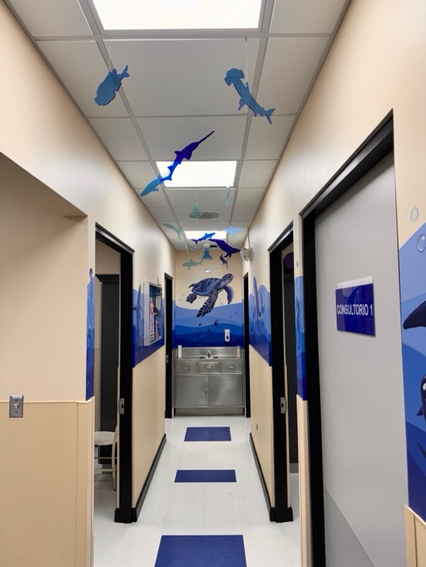

In addition to the corridor itself, the IACT team and hospital staff collaboratively designed and refurbished three different rooms where child and adolescent trafficking victims and other children and adolescents visiting the hospital can meet with healthcare providers, psychologists, social workers, and other professionals. The design of each space was based on feedback from children and adolescents who shared with the IACT Program what makes them feel safe, calm, and comfortable.

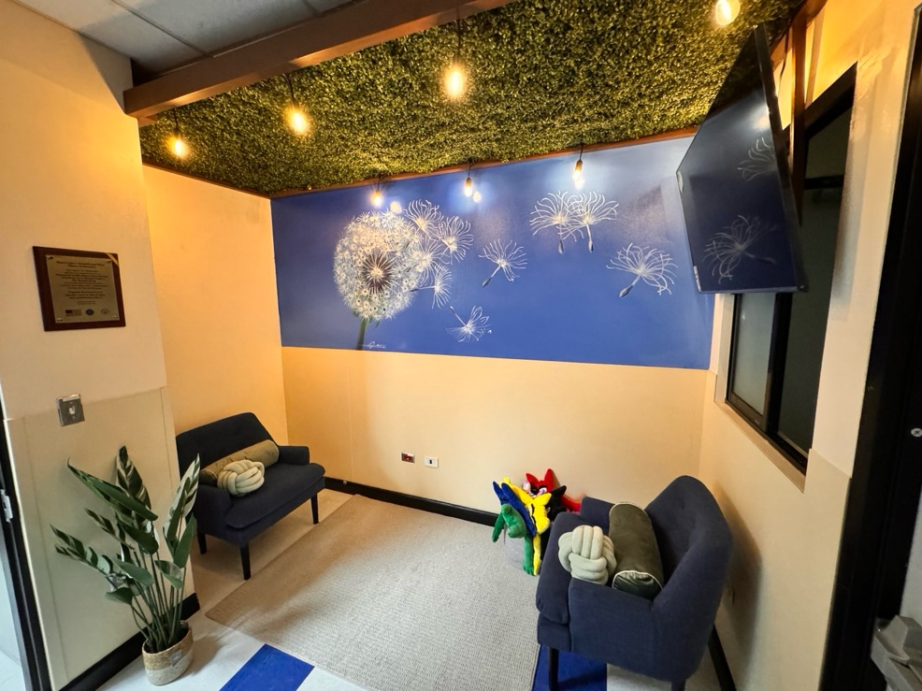

In the Social Work Family Therapy Room, child and adolescent trafficking victims and their family members can meet with social workers and other practitioners. Warnath Group designed this room to include warm lightning, connections to nature, comfortable furniture, and locally-crafted toys. The painting of a dandelion blowing across the wall symbolizes hope, healing, and resilience.

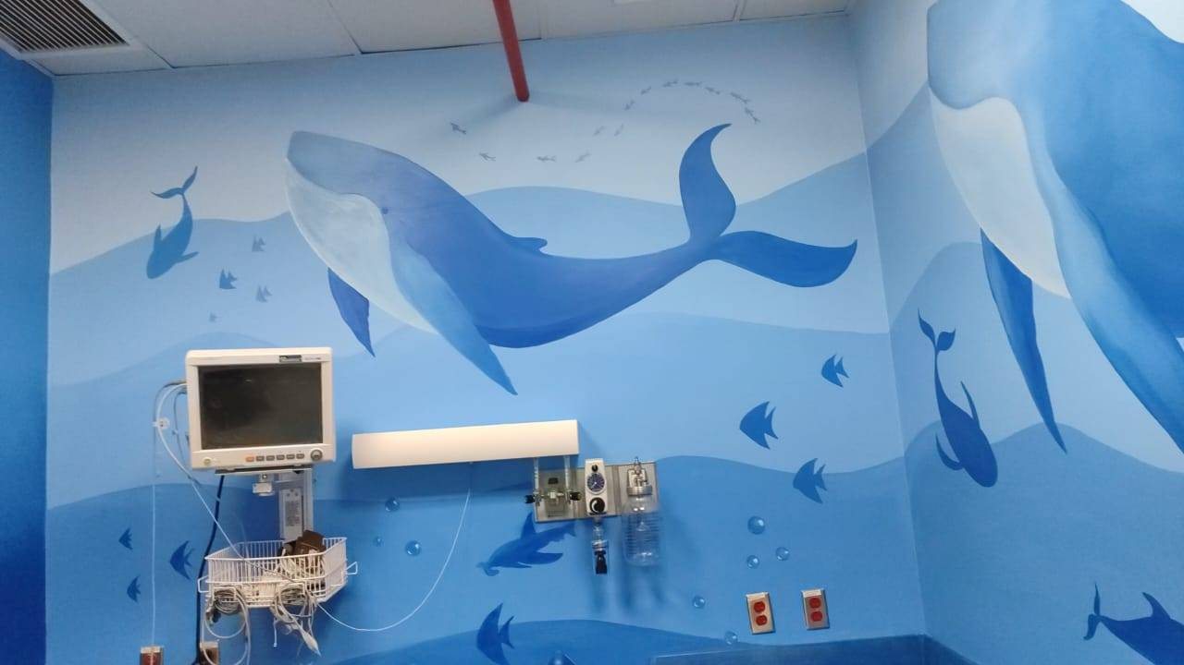

In the Examination Room, medical professionals provide medical treatment to children and adolescents. Here, whales float among the waves on the walls. While children or adolescents lie down for their examination, they can look up at the ceiling where sharks, whales, and different tropical fish swim and frolic above. The adjoining restroom also includes sea creature cutouts.

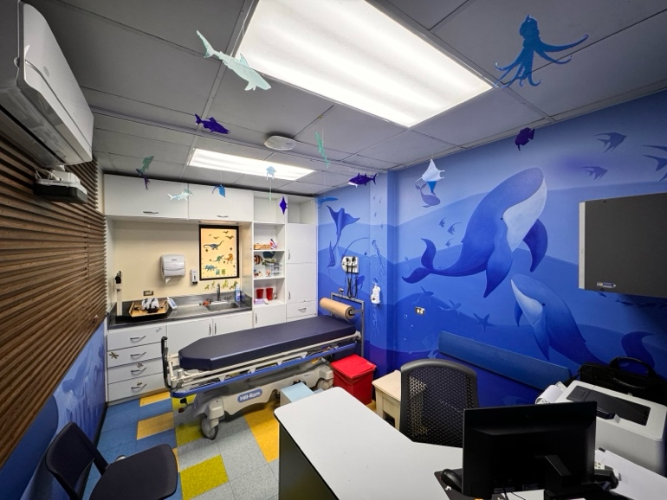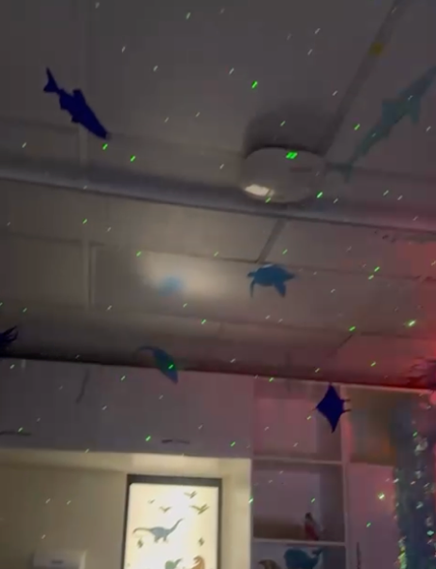

The sea creatures follow children and adolescents to the Pediatric Consultation and Examination Room, where medical professionals conduct examinations and provide medical care. This room features special sensory lights, which can be turned on to create a calming and stimulating environment for children and adolescents, reducing anxiety and helping them to feel more comfortable and at ease.

Hospital staff report that these child-friendly spaces, with the ocean setting and other connections to the natural environment in this part of Costa Rica, have been extremely well received by children and parents alike. As one social worker observed, “Children are crying when they get there, but when they see all the animals… they stop crying. The parents are always so happy they don't want to leave the office afterward.”

In addition to creating physical spaces that are safe, calm, and comfortable for child and adolescent trafficking victims who are receiving assistance, these child-friendly spaces were developed to foster opportunities for cooperation and partnerships between different institutions working to protect child and adolescent trafficking victims. The therapy rooms can be used by prosecutors and/or law enforcement to meet with and interview child and adolescent trafficking victims in coordination with hospital staff. Healthcare professionals, social workers, psychologists, administrative professionals, and others are using the spaces every day. These are safe places to tell practitioners what has happened, to be counseled, and to receive assistance. Ultimately, such spaces provide a genesis in the process of restoring normalcy and continuity to the lives of trafficked children and adolescents.